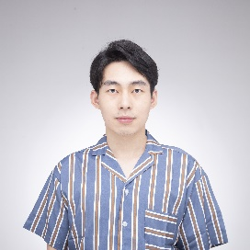
z

Jinda Li Software Developer

jinda.li@outlook.com
https://neiljnda.github.io/
https://www.linkedin.com/in/jinda-li/





WORK EXPERIENCE


Unity Developer Feb. 2024 - Mar. 2025
Mixed Reality, Microsoft
Research projects to deliver state-of-the-art products
Cross-platform VR Tools: Developed Unity-based AR-in-VR simulator for research, integrating 3D holographic rendering, eye-tracking, night vision, etc.
HoloLens2 Applications: Engineered AR applications with gesture-based interactions.

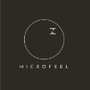
AI Developer Sep. 2023 - Apr. 2024
AI-Driven Open World Engine, Microfeel
Start-up company focusing on Generative AI and UGC in Games
Implemented AI procedural building generation using LLMs in Unreal with Python and C++.
Pioneered 3D Gaussian Splatting rendering in Unity for real-time photorealistic scene reconstruction.

Game Operation Specialist Apr. 2023 - Dec. 2023
App Gallery
Launched game campaigns for user acquisition and engagement.
Grew Discord communities for promoted games via player engagement and support.


SKILLS
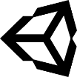 |  |  | 
Unity | Unreal | C++/C# | Shader
 |  |  | 

 |  |  | 
VR/AR | Python | Git | JavaScript
 |  |  | 
 |  |  | 
React | Parallel Programming | Blender | Linux
 |  |  | 


EDUCATION
Game Design and Production, Aalto University
Master of Science 2021- 2025

Average Grade: 4.73/5
Thesis Project:
- A Cloud’s Adventure: Particle-based cloud simulation and custom rendering.

Courses Taken:
- Full Stack Web Development (Project: A blog collection website developed with React, Redux, and Node.js).
- Programming Parallel Computers (Hands-on experience in writing high-performance C++ codes).
- Web Software Development, Machine Learning, Computer Graphics.

Electrical Engineering, Southeast University (China)
Bachelor of Engineering 2016-2020
Average Grade: 3.56/4.0
• Received Merit Student Award and Academic Scholarship.
• Participated in the research of variable flux permanent magnet and complied DLL script for analysis. A paper published on AIP Advances 9, 095056(2019)

